

<Project Name/Project ID>

Issue Log
Version X.X
DD/MM/YYYY

Document Tracking
The following chart is used to log of all changes made to this document.
Version | Date of edit/change | Who made the edit/change | Description of edit/change
0.1 | Jan 21, 2022 | Mary True (PM) | Initial version
1.0 | Jan 21, 2022 | Mary True (PM) | Final version

Introduction
Green World company is a new re-cycling concept organization based in Hong Kong which established on Jan 1, 2026.
Green World’s products were donated by the public and sell to the public with discounted price.
So far, customers need to visit the physical stores to purchase the products.
Green World would like to sell products online and would like to set up an E-shop/website to display their company’s information, product information and be able to sell products online if possible.
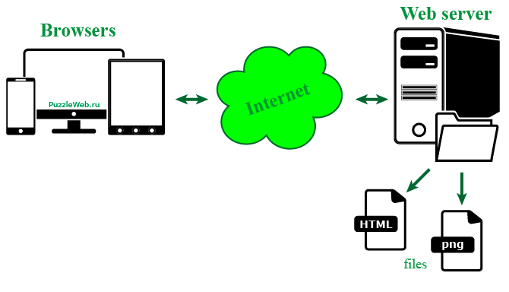

Issue Log

Issue# | Description | Date open | Assign to | Date Assigned | Date Complete | Status
1 | Added user requirement R4 to backlog | Feb 21, 2026 | David King | Feb 21, 2026 | Jan 22, 2026 | Completed
2 | User story missed due date | Feb 29, 2026 | Sean Powell | Feb 29, 2026 |  | In progress

